CHAPTER 1

INTRODUCTION

  - PERSCPECTIVE

Tamil palm-leaf manuscripts are valuable sources of traditional knowledge, including literature, medicine, history, philosophy and cultural practices. Physical deterioration can cause letters to fade, leaves to crack and portions of text to become unreadable. Scanning alone preserves an image but does not necessarily make its content searchable or easy to analyze.
The Tamil Palm-Leaf Manuscript Digitizer & Intelligent Analysis System is designed as a browser-based tool to bring manuscript images, extracted text and descriptive metadata into a centralized repository. The system specification describes a workflow combining image preprocessing, restoration, Tamil OCR, text cleaning, metadata storage and intelligent discovery features.
The project documentation identifies three broad user groups: students and researchers who browse and study records; historians or experts who review and enrich manuscript information; and administrators who manage users and system-level information. Access-control details should be checked against the active application routes before being described as fully implemented.

  - OBJECTIVE

The main objective is to support the digital preservation and research use of Tamil palm-leaf manuscripts by organizing original images, processed images, OCR text and metadata in a searchable system.
- Provide a web interface for uploading and validating manuscript images.
- Support image enhancement and the proposed restoration workflow.
- Extract Tamil text using OCR and retain raw and cleaned versions separately.
- Store manuscript information and associated metadata in a structured repository.
- Enable keyword search, filtering, tagging, catalogue browsing and location-based views.
- Provide comparison and analytics features to assist manuscript study.
  - SCOPE

The scope described in the project includes image upload, preprocessing, restoration, OCR extraction, text cleaning, manuscript storage, metadata management, historical map visualization, artifact and symbol analysis, script classification, knowledge tagging, search and retrieval, comparison, analytics, and achievement highlights.
The database scripts also support catalogue-style records for TDL and CICT sources. Catalogue entries must be distinguished from manuscripts that have actually been processed: a catalogue title alone does not imply that an image was uploaded, OCR was run, or an AI prediction was generated.
Author identification, a dedicated mobile application and cloud deployment are treated as possible future work in the project notes. Classification of dynasty, period or region should be treated as an estimate unless verified by a qualified expert.

CHAPTER 2

REQUIREMENT DESCRIPTION

2.1 FUNCTIONAL REQUIREMENTS

The functional requirement in Food Waste Management System is the collective information about what are the operations available in the system.
- It should provide the functionality of authentication for valid users by maintaining their username, email, password and role.
- It should provide the functionality for uploading Tamil palm-leaf manuscript images in supported formats such as JPG and PNG.
- It should provide the functionality for processing and restoring uploaded images to improve their quality and readability.
- It should provide the functionality for extracting Tamil text from manuscript images using Optical Character Recognition (OCR).
- It should provide the functionality for cleaning the extracted text while preserving the original OCR output.
- It should provide the functionality for storing and managing manuscript details such as title, category, dynasty, period and location.
- It should provide the functionality for adding metadata and tags to manuscripts for easy identification and retrieval.
- It should provide the functionality for searching and filtering manuscripts based on text, category, dynasty, period and other available details.
- It should provide the functionality for classifying manuscript scripts and analyzing symbols and artifacts, where supported by the implemented modules.
- It should provide the functionality for integrating external manuscript catalogues, such as TDL and CICT, to store catalogue details and source links.
- It should provide the functionality for displaying the geographical locations of manuscripts on a map.

2.2 NON-FUNCTIONAL REQUIREMENT
The non-functional requirements describe the quality attributes and constraints that the Tamil Palm-Leaf Manuscript Digitizer and Intelligent Analysis System should satisfy.
- It should provide a user-friendly interface that allows users to access the available features easily.
- It should provide reliable storage and retrieval of manuscript information.
- It should maintain the accuracy and consistency of stored manuscript metadata and extracted text.
- It should provide acceptable response time for uploading images, processing text and searching manuscript records.
- It should provide security for user information and restrict access according to the assigned user roles.
- It should preserve the original manuscript images and raw OCR text for future reference.
- It should support the processing of multiple manuscript records as the repository grows.
- It should provide maintainability so that new features and processing modules can be added in the future.
- It should provide compatibility with the required software environment and supported web browsers.

CHAPTER 3

SYSTEM DESIGN

3.1 ARCHITECTURE DESIGN

The architectural design describes the overall workflow of the Tamil Palm-Leaf Manuscript Digitizer and Intelligent Analysis System. The process begins when a user accesses the application. The user logs in through the authentication system to access the available functionalities. After authentication, the user can upload palm-leaf manuscript images for digitization and analysis.
The uploaded images are processed by the image-processing module to improve their quality and readability. The OCR module extracts Tamil text from the images, and the text-cleaning module processes the extracted content while retaining the original OCR output. The manuscript details, images, extracted text, and metadata are stored in the database for future reference.
Users can search and filter manuscript records, view catalogue information, compare manuscripts, and explore geographical locations through map visualization. The system also supports analytical summaries and other manuscript-related functionalities through the corresponding modules.

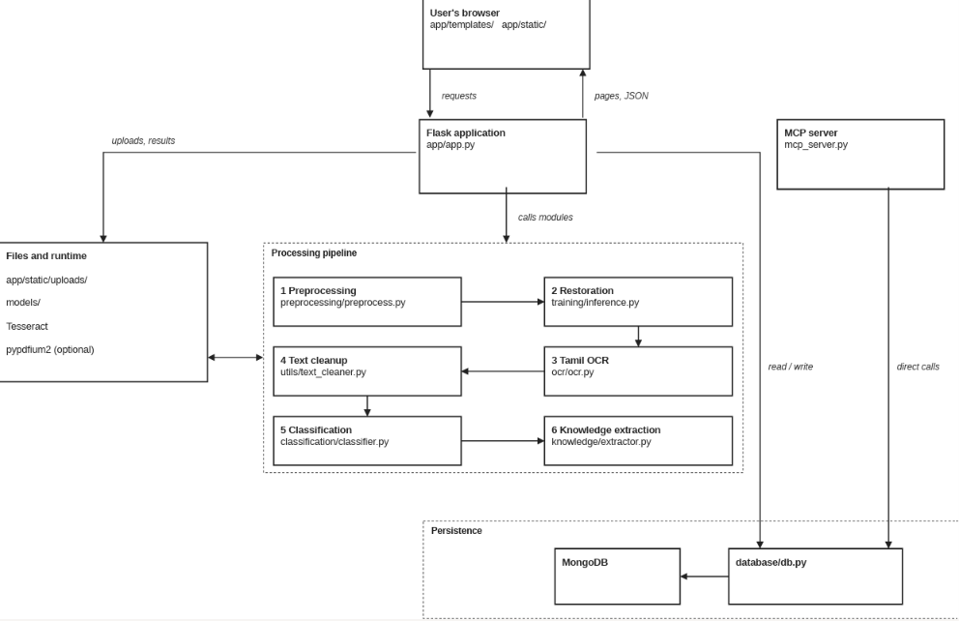

Figure 3.1: Architecture Diagram of Tamil Palm-Leaf Manuscript Digitizer and Intelligent Analysis System.

3.2 UML DIAGRAMS:
The figure3.2 shows the This use case diagram represents the functionalities of the manuscript management system and its interactions with different users.
The Guest can register, log in, browse the repository, and view manuscript details, while registered users can upload, compare, and manage manuscripts.
The Admin can administer users and view system logs, while the MCP client accesses tools to search manuscripts, retrieve records, and view historical locations and mind-map nodes.
Overall, the diagram illustrates the roles and permissions of each actor within the system.
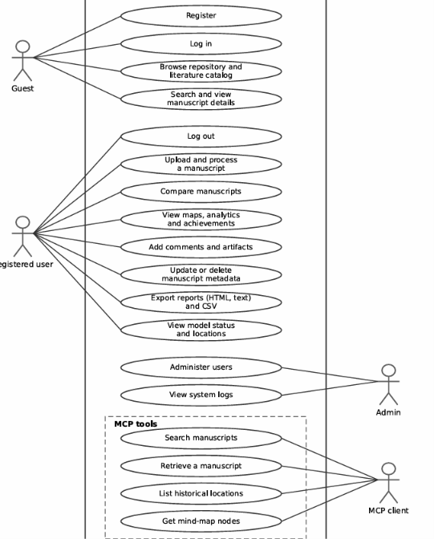
Figure 3.2:Usecase Diagram
The figure 3.3 shows the sequence diagram illustrates the interaction between the user, Web UI, backend, ML models, OCR engine, and database.
The user uploads an image, which the backend validates and processes before restoring it using ML models. The restored image undergoes OCR, and the extracted text is cleaned before the processed record is saved in the database.
Finally, the backend returns the results to the Web UI, which displays them to the user.
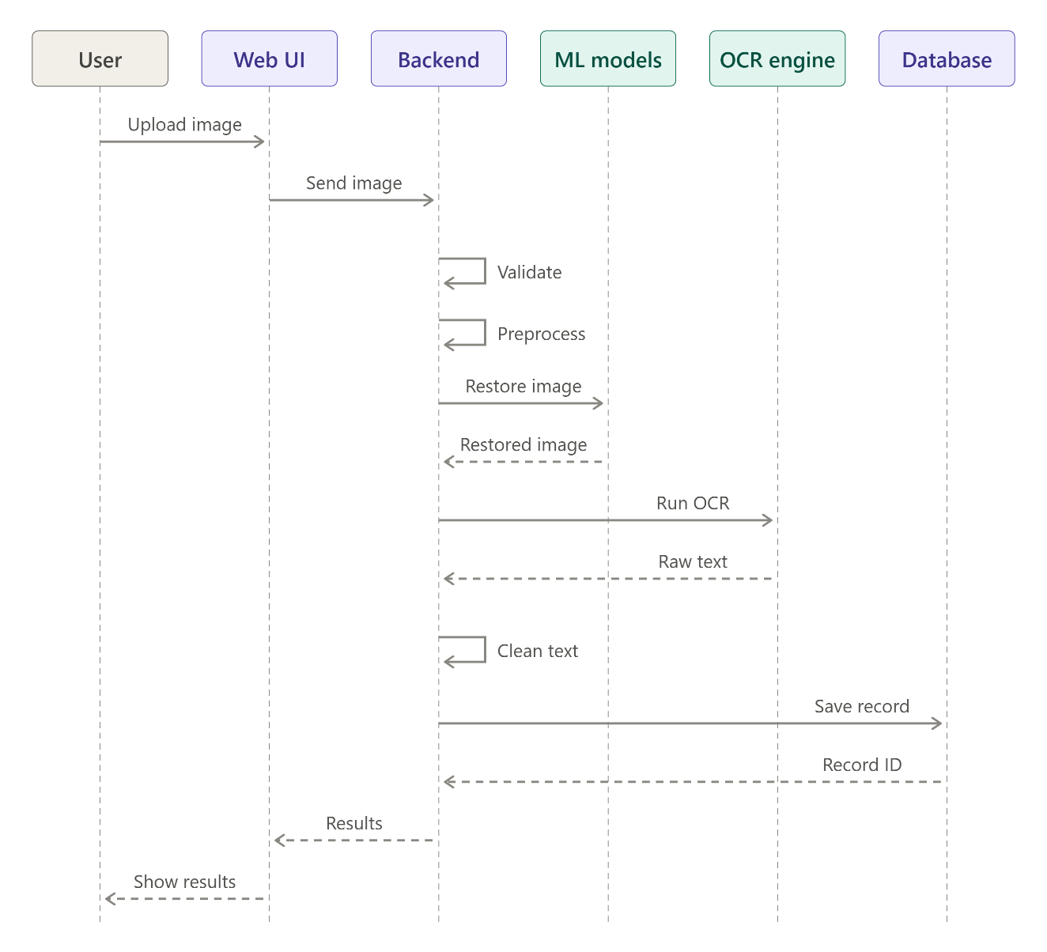
Figure 3.3 Sequence Diagram

The figure 3.4 shows the class diagram represents the structure of the manuscript management system, including its classes, attributes, methods, and relationships.
It includes classes such as User, Manuscript, Image, OCRResult, CleanedText, Author, Script, Location, Artifact, and Reference.The MLModel and SearchService classes support image processing, text analysis, and manuscript searching.
Overall, the diagram describes how the system’s components interact to manage manuscripts, extract text, store metadata, and support searching.

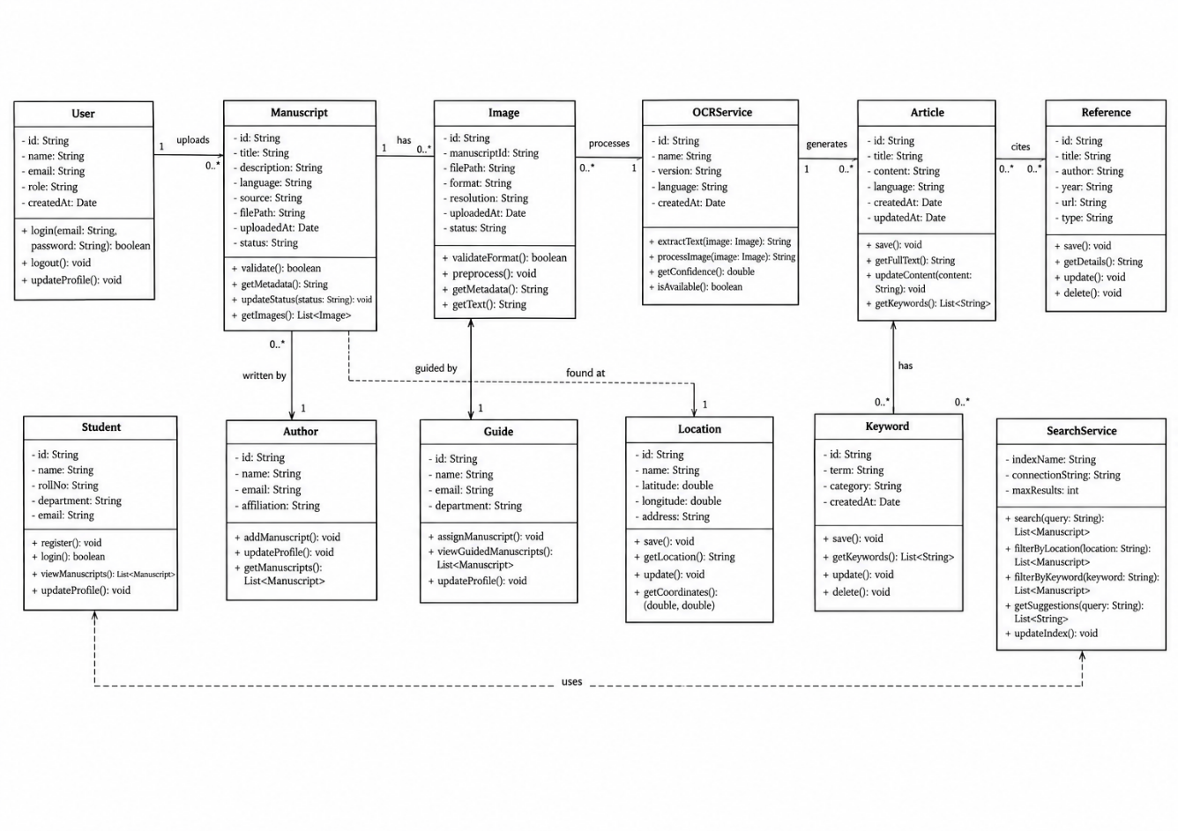
Figure 3.4 :Class Diagram

The activity figure 3.6 shows the workflow of the proposed system, starting with user login and credential verification. It shows manuscript image uploading, validation, image restoration, and Tamil text extraction using Tesseract OCR. The extracted text, images, and metadata are stored in the MongoDB database. Finally, users can search and filter records, view locations on a map, and access the analytics dashboard to view the results.
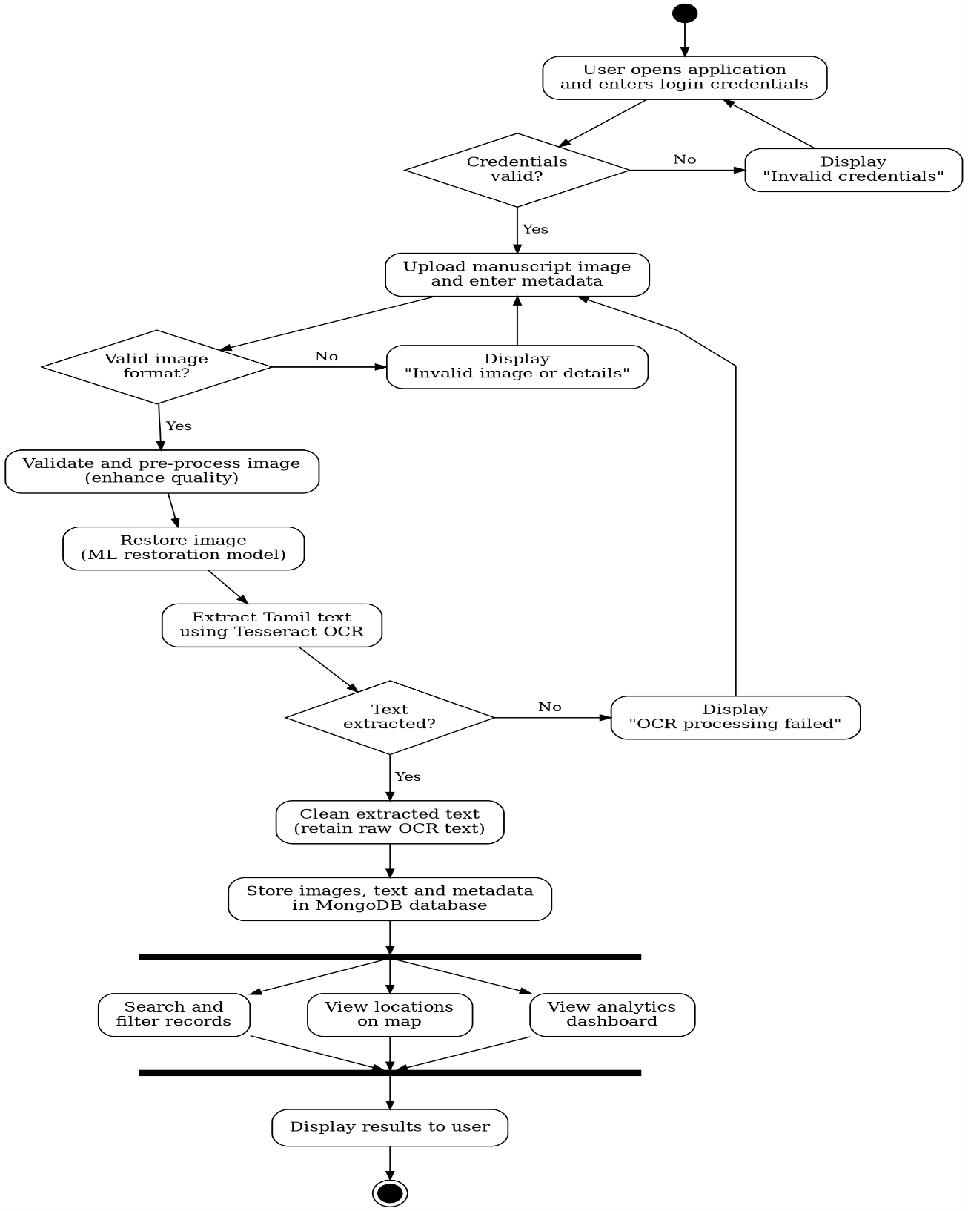

Figure 3.5 Activity Diagram
3.3 DESIGN COMPONENTS
3.3.1 Front End:
The frontend is developed using HTML, CSS, and JavaScript to provide an interactive web interface. It allows users to log in, upload manuscript images, view extracted Tamil text, search manuscript records, and access the available analysis and visualization features.
3.3.2 Back End:
The backend is developed using Python and the Flask framework to handle user requests and coordinate the application's operations. It connects the frontend with the database and processing modules, including image processing, OCR, text cleaning, and manuscript record management.
3.4 DATABASE DESCRIPTION
The following section describes the database collections and their document schemas used in the Tamil Palm-Leaf Manuscript Digitizer and Intelligent Analysis System. The database maintains user details, manuscript information, metadata, and supporting records required for digitization, storage, searching, and analysis.
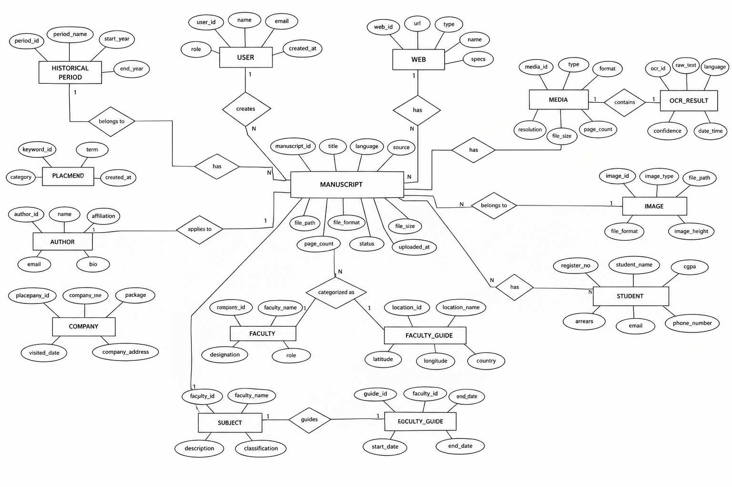
Fig 3.6 Entity Relationship Diagram

3.4.1 User Structure
As shown in table 3.1, user structure contains the details of the users.
Table 3.1: User Description
Attribute Name | Type | Width | Constraint(s) | Description
Id | Integer |  | Primary Key | Unique ID assigned to the user
Name | String | 100 | Required | Username of the user
email | String | 100 | unique | Email address of the user
Password-hash | String | 50 | Required | Hashed password used for authentication
role | String | 30 | Required | Role assigned to the user
Created_at | Datetime |  |  | Date and time when the user record was created

3.4.2 Manuscript structure
The manuscript structure stores the details of palm-leaf manuscripts uploaded to the application. It maintains descriptive information, image references, and extracted text.
Table 3.2:Manuscript Description
Attribute Name | Type | Width | Constraint(s) | Description
Id | Integer |  | PrimaryKey | Unique ID assigned to the manuscript
Title | String | 100 | Required | Title of the manuscript
Category | String | 100 | optional | Category of the manuscript
Dynasty | String | 100 | optional | Dynasty associated with the manuscript
Period | String | 100 | optional | Historical period of the manuscript
Location | String | 200 | optional | Location associated with the manuscript
Original_path | String | 255 | Required | Path of the original manuscript image
Restored_path | String | 255 | optional | Path of the restored manuscript image
Raw_text | String |  |  | Text extracted from the manuscript image through OCR
Cleaned_text | String |  |  | Cleaned version of the extracted text
Created_at | DateTime |  |  | Date and time when the manuscript record was created

3.4.3 Tags Structure
The tags structure stores keywords associated with manuscript records to support categorization and retrieval.
Table 3.3: Tags Description
Attribute Name | Type | Width | Constraint(s) | Description
Manuscript_id | Integer |  | ForeignKey | Id of the associated manuscripted
Tag | String | 100 | Required | Keyword assigned to the manuscript
Category | String | 100 | Optional | Category of the tag

3.4.4 Artifacts Structure
The artifacts structure maintains information about symbols and artifacts associated with manuscripts.
Table 3.4: Artifacts Description
Attribute Name | Type | Width | Constraint(s) | Description
Manuscript_id | Integer |  | ForeignKey | ID of the associated manuscript
Name | String | 50 | Required | Name of the artifact
Description | String | 300 | Optional | Description of the artifact
Symbol | String | 100 | Optional | Symbol associated with the artifact
Created_at | datetime |  |  | Date and time when the artifact record was created

3.4.5 Achievements Structure
The achievements structure maintains achievement-related information associated with manuscript records.
Table 3.5: Achievements Description
Attribute Name | Type | Width | Constraint(s) | Description
Manuscript_id | Integer |  | ForeignKey | ID of the associated manuscript
Title | String | 150 | Required | Name of the achievement
Description | String | 300 | Optional | Description of the achievement
Awarded_at | DateTime |  |  | Date amd time when the achievement was recorded

3.4.6 Locations Structure
The locations structure stores geographical information associated with manuscript collections and supports map visualization.
Table 3.6: Locations Description
Attribute Name | Type | Width | Constraint(s) | Description
location_name | String | 150 | Rquired | Name of the location
location_type | String | 50 | Optional | Type or category of the location
latitude | Float |  |  | Latitude coordinate of the location
longitude | Float |  |  | Longitude coordinate of the location
region | String | 100 | Optional | Region associated with the location

3.4.7 System Logs Structure
The system logs structure records relevant activities performed within the application.
Table 3.7: System Logs Description
Attribute Name | Type | Width | Constraint(s) | Description
Action | String | 100 | Required | Action performed in the system
User_name | String | 100 | Required | Name of the user associated with the action
Details | String | 300 | Optional | Additional information about the activity
Created_at | Datetime |  |  | Date and time when the activity was recorded

3.4.8 TDL Catalogue Structure
The TDL catalogue structure stores source information obtained from the Tamil Digital Library catalogue.
Table 3.8: TDL Catalogue Description
Attribute Name | Type | Width | Constraint(s) | Description
source_id | String | 100 | PrimaryKey | Identifier of the source catalogue record
Title | String | 250 | Required | Title of the catalogue entry
Publisher | String | 150 | Optional | Publisher organization
Subject | String | 150 | Optional | Subject associated with the catalogue entry
Source_url | String | 150 | Check | URL of the source record

3.4.9 CICT Catalogue Structure
The CICT catalogue structure maintains catalogue information associated with CICT sources.
Table 3.9: CICT Catalogue Description
Attribute Name | Type | Width | Constraint(s) | Description
Source_id | String | 100 | Primary Key | Identifier of the source catalogue record
Title | String | 250 | Required | Title of the catalogue entry
Collection | String | 150 | Optional | Name of the associated collection
Source_count | Integer |  |  | Number of source records, where available
Pothi_count | Integer |  |  | Number of pothis or manuscript units, where available
Source_url | String | 500 | Check | URL of the source record

3.5 LOW LEVEL DESIGN
The following section describes the detailed functionalities of the Tamil Palm-Leaf Manuscript Digitizer and Intelligent Analysis System. It explains the operations performed by each module, including user authentication, manuscript image uploading, image processing, Tamil text extraction, text cleaning, manuscript searching, and data management.
3.4.1 Login
Table 3.10 shows the login details of the application.
Table 3.10 Login Details
Files used | Flask authentication routes and related frontend files
Short Description | Allows registered users to log in to the application using their credentials.
Arguments | Email/Username, Password
Return | Successful login or an authentication error message
Pre-Condition | The user must have a registered account.
Post-Condition | The user is authenticated and redirected to the appropriate application page.
Exception | Invalid credentials or authentication failure
Actor | Registered User

3.4.2 Manuscript Image Upload
Table 3.11 describes the manuscript image upload functionality.
Table 3.11:Manuscript Details
Files used | Manuscript upload interface and related backend files
Short Description | Allows users to upload palm-leaf manuscript images for digitization and analysis.
Arguments | Manuscript Image, Title, Category, and Available Metadata
Return | Upload success message or an error message
Pre-Condition | The application must be accessible, and the selected image must be in a supported format.
Post-Condition | The uploaded image and associated information are recorded for further processing.
Exception | Unsupported file format, invalid image, or upload failure
Actor | User

3.4.3 Image Processing and Restoration
Table 3.12 describes the image-processing and restoration functionality.
Table 3.12:Image Processing Details
Files used | Image-processing and restoration modules, where implemented
Short Description | Improves the visual quality and readability of uploaded manuscript images.
Arguments | Uploaded Manuscript Image and Processing Parameters
Return | Processed or restored image
Pre-Condition | A valid manuscript image must be available.
Post-Condition | The processed image is made available for viewing or further analysis.
Exception | Invalid image data or processing failure
Actor | User

3.4.4 Tamil OCR
Table 3.13 describes the Tamil Optical Character Recognition functionality.
Table 3.13:Tamil OCR Details
Files used | OCR processing module and configured Tesseract OCR installation
Short Description | Extracts Tamil text from uploaded manuscript images.
Arguments | Manuscript Image and Tamil OCR Configuration
Return | Extracted Tamil text
Pre-Condition | A valid manuscript image must be available, and Tamil language support must be configured.
Post-Condition | The extracted text becomes available for cleaning and storage.
Exception | OCR engine failure, missing language data, or unreadable image
Actor | User / System
3.4.5 Text Cleaning
Table 3.14 describes the text-cleaning functionality.
Table 3.14 Text Cleaning Details
Files used | Text-cleaning module, where implemented
Short Description | Processes OCR output to improve its readability while retaining the original extracted text.
Arguments | Raw OCR Text
Return | Cleaned Text
Pre-Condition | OCR text must be available.
Post-Condition | The cleaned text is available for display, storage, or searching.
Exception | Empty OCR output or text-processing failure
Actor | System / User

3.4.6 Manuscript Management
Table 3.15 describes the manuscript management functionality.
Table 3.15: Manuscript Management Details
Files used | Manuscript management routes and database operations
Short Description | Maintains manuscript records and their descriptive information.
Arguments | Manuscript ID, Title, Category, Dynasty, Period, Location, and Available Text and Image References
Return | Stored or retrieved manuscript information
Pre-Condition | The application must be connected to the configured database.
Post-Condition | Manuscript information is stored or retrieved for further use.
Exception | Database connection failure, invalid data, or record retrieval failure
Actor | User / System

3.4.7 Search and Filtering
Table 3.16 describes the manuscript search and filtering functionality.
Table 3.16: Search and Filtering Details

Files used | Search interface and related backend/database operations
Short Description | Allows users to retrieve manuscripts using keywords and available metadata.
Arguments | Search Keyword, Category, Dynasty, Period, or Other Available Filters
Return | Matching manuscript records
Pre-Condition | Manuscript records must be available in the database.
Post-Condition | Relevant records are displayed to the user.
Exception | Invalid search input or database retrieval failure
Actor | User

3.4.8 Catalogue Management
Table 3.17 describes the catalogue management functionality.
Table 3.17 : Catalogue Management Details
Files used | TDL and CICT catalogue ingestion and database modules
Short Description | Maintains external catalogue information and source references.
Arguments | Catalogue Source, Source ID, Title, and Source URL
Return | Stored or retrieved catalogue records
Pre-Condition | Catalogue data must be available for ingestion or retrieval.
Post-Condition | Catalogue information is maintained in the database.
Exception | Invalid catalogue data, unavailable source, or database failure
Actor | User / System

3.4.9 Map Visualization
Table 3.18 describes the geographical map visualization functionality.
Table 3.18: Map Visualization Details
Files used | Map interface and location-related database components
Short Description | Displays the geographical locations associated with available manuscript records.
Arguments | Location Name, Latitude, Longitude, and Region
Return | Map displaying the available manuscript locations
Pre-Condition | Geographical information must be available, and the map component must be configured.
Post-Condition | The available locations are displayed for exploration.
Exception | Missing geographical coordinates or map-loading failure
Actor | User
3.6 USER INTERFACE DESIGN

3.6.1 Home Dashboard
Figure 3.7 provide the interface for the home page

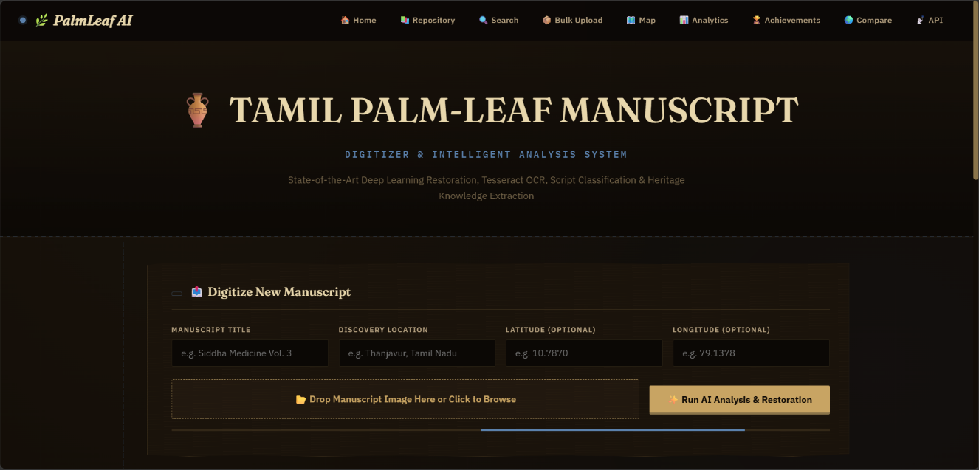

Figure 3.7: Home dashboard

3.6.2 Manuscript Repository

Figure 3.8 provides the interface for viewing and accessing digitized manuscript records with their details.
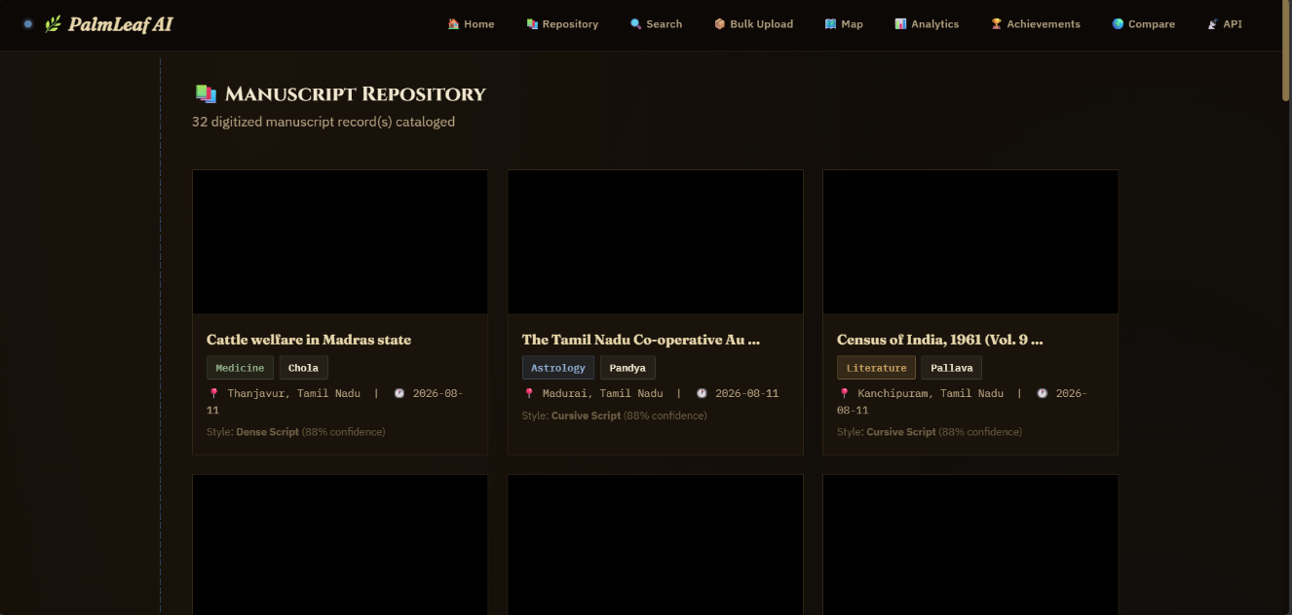
Figure 3.8: Manuscript Repository

3.6.3 Intelligent Manuscript Search

Figure 3.9 provides the interface for searching manuscripts using keywords, subject categories, and dynasties.

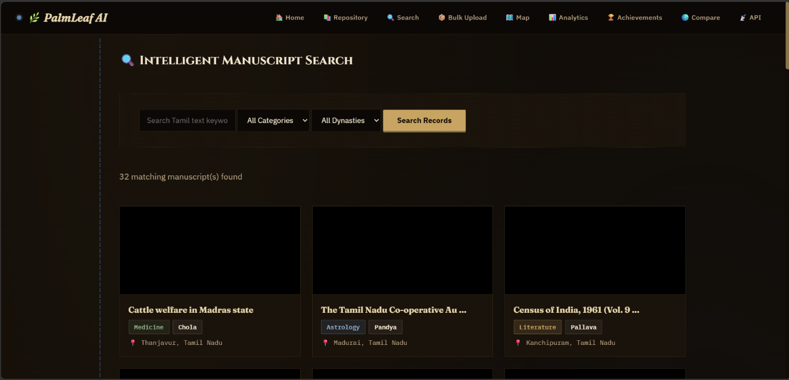
Figure 3.9: Intelligent Manuscript Search

3.6.4 Batch Manuscript Ingestion

Figure 3.10 provides the interface for uploading and processing multiple manuscript images simultaneously using AI.

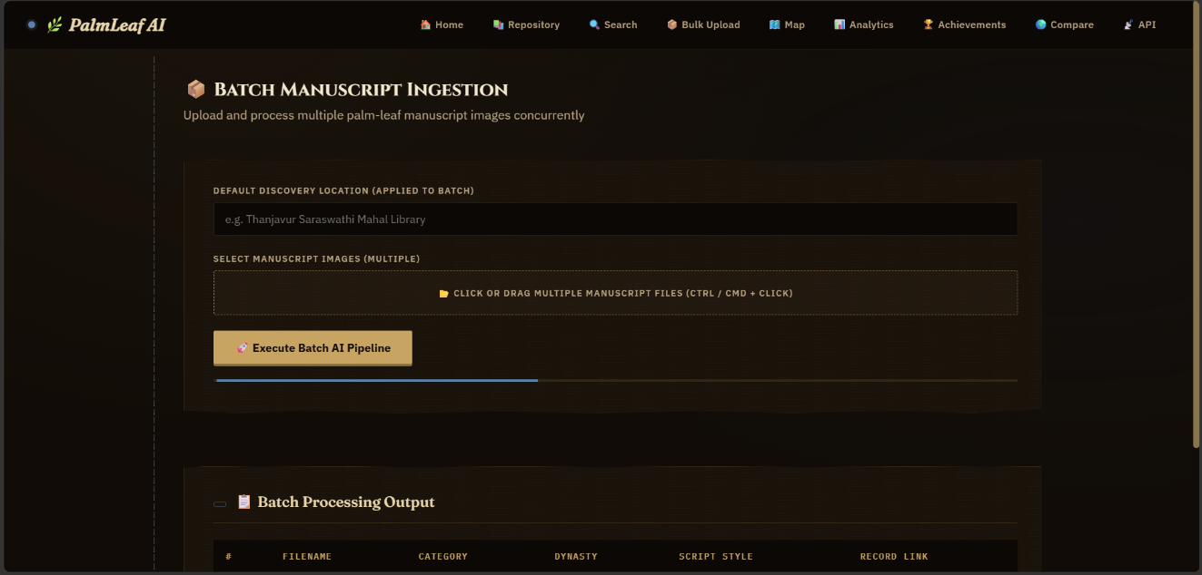

Figure 3.10: Batch Manuscript Ingestion

3.6.5 Analytics and Statistical Dashboard

Figure 3.11 provides the interface for displaying manuscript statistics through charts representing subjects, dynasties, and historical periods.

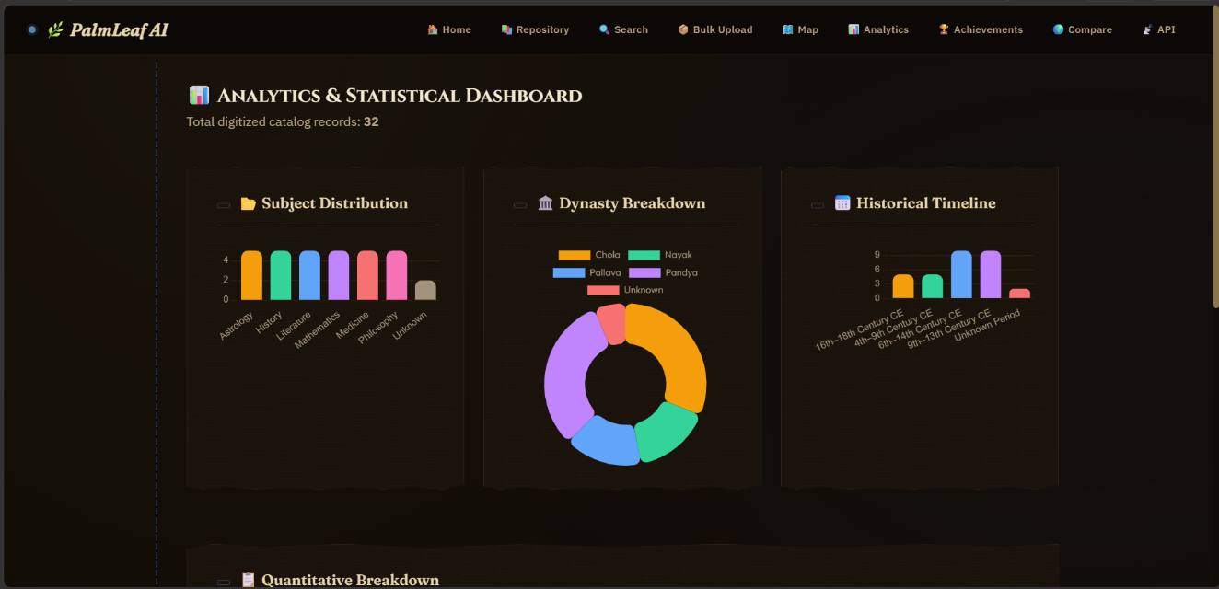
Figure 3.11: Analytics and Statistical Dashboard

3.6.6 Discovery Location Index

Figure 3.12 provides the interface for viewing manuscript titles, discovery locations, subject categories, and geographical coordinates.

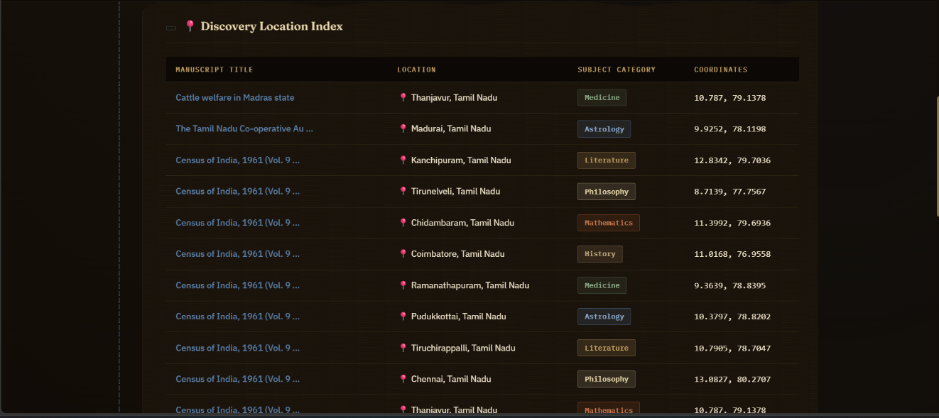
Figure 3.12: Discovery Location Index

3.6.7 Visual Processing Pipeline

Figure 3.13 provides the interface for comparing original, denoised, and AI-restored manuscript images.

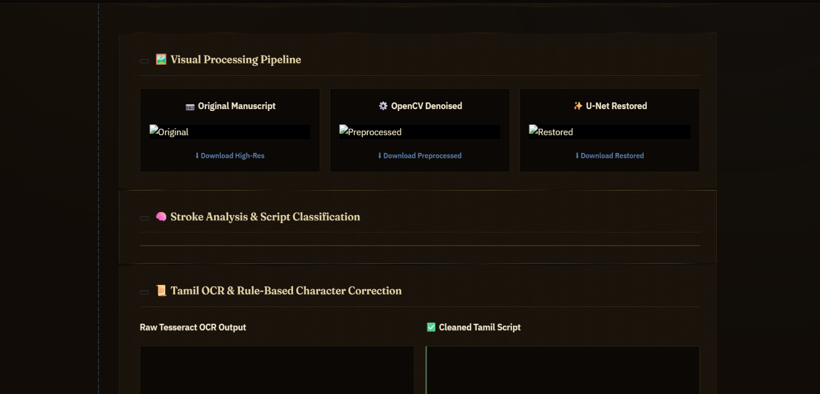

Figure 3.13: Visual Processing Pipeline
3.6.8 Tamil OCR and Character Correction
Figure 3.14 provides the interface for displaying and correcting Tamil text extracted from manuscript images using OCR.

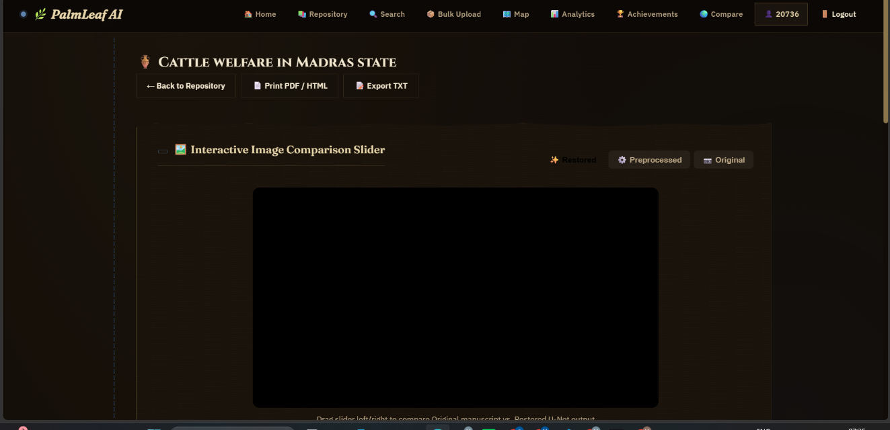
Figure 3.14: Tamil OCR and Character Correction
3.6.9 Extracted Tamil Text and Scholarly Annotations

Figure 3.10 provides the interface for viewing, copying, and downloading extracted Tamil text and adding scholarly research notes.

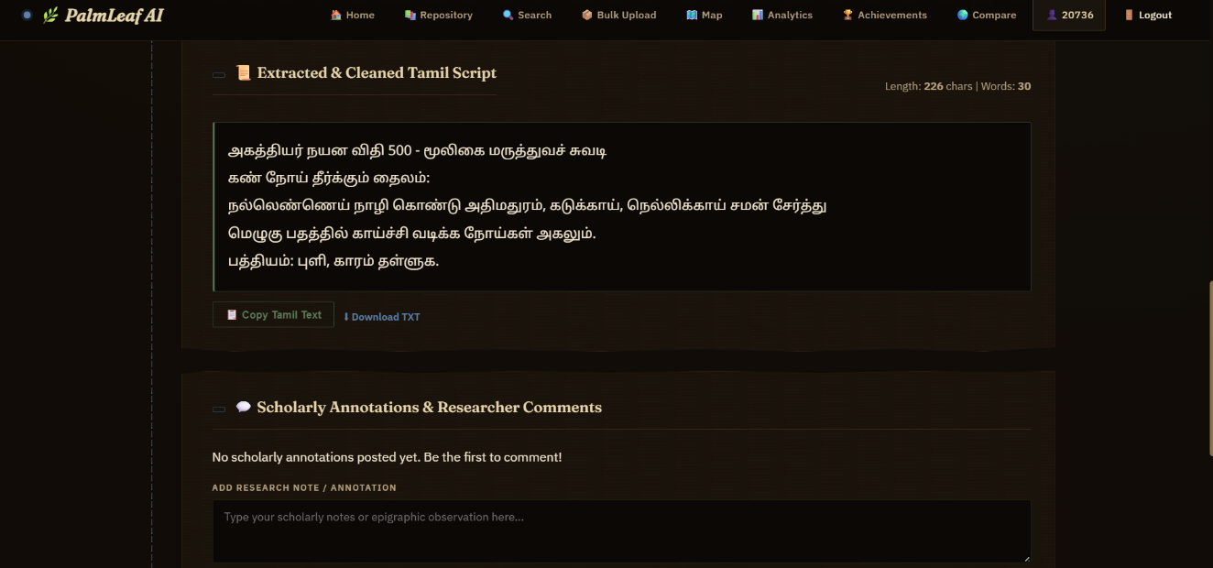

Figure 3.10: Extracted Tamil Text and Scholarly Annotations

3.6.10 Historical Discovery and Preservation Maps

Figure 3.10 provides the interface for exploring historical manuscript discovery locations and modern preservation archives through interactive maps.

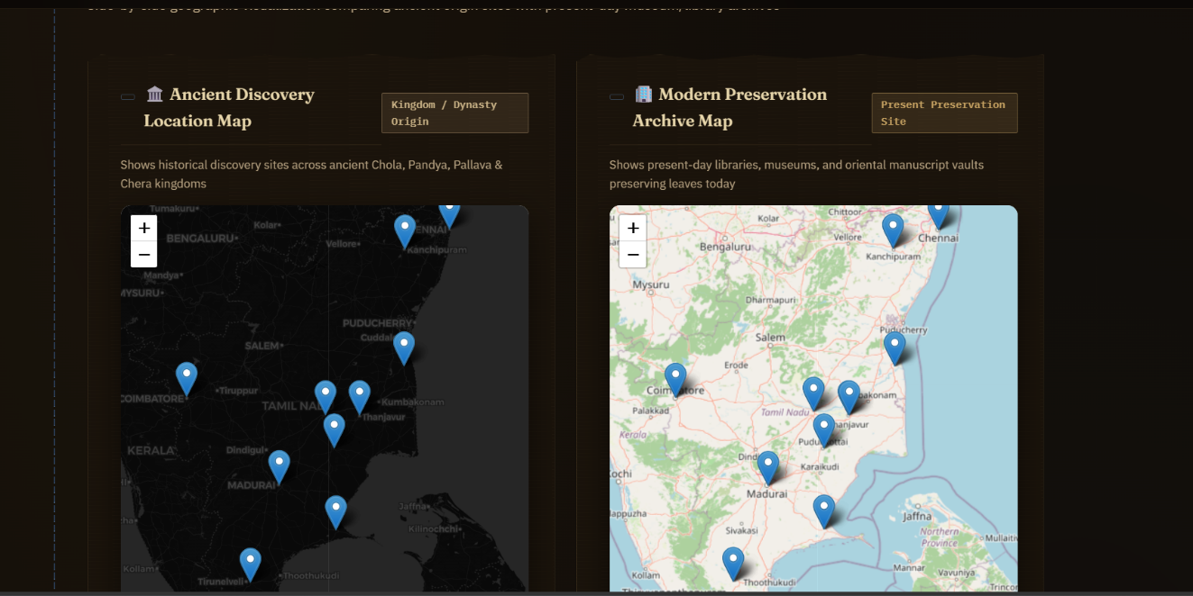
Figure 3.12: Historical Discovery and Preservation Maps

CHAPTER 4

SYSTEM IMPLEMENTATION

4.1 LOGIN IMPLEMENTATION
The login functionality verifies the credentials entered by the registered user. If the credentials are valid, the user is authenticated and redirected to the homepage. Otherwise, an error message is displayed.

GET username/email, password
IF username/email and password are valid
AUTHENTICATE user
RETURN homepage
ELSE
DISPLAY "Invalid credentials"
END IF
4.2 SIGNUP IMPLEMENTATION
The signup functionality collects the user's registration details and validates the submitted information. If the details are valid, a new user record is created in the database. Otherwise, an error message is displayed.

GET username, email, password, role
IF registration details are valid
HASH password
STORE user details in database
DISPLAY "Registration successful"
ELSE
DISPLAY "Enter valid details"
END IF

4.3 MANUSCRIPT IMAGE UPLOAD IMPLEMENTATION
The image upload functionality allows users to upload palm-leaf manuscript images for digitization. The system checks the submitted image and, if it is valid, stores the image reference for further processing.

GET manuscript image and metadata
IF image and required details are valid
STORE image reference and manuscript details
DISPLAY "Upload successful"
ELSE
DISPLAY "Invalid image or details"
END IF

4.4 IMAGE PROCESSING AND RESTORATION IMPLEMENTATION
The image-processing functionality improves the quality and readability of uploaded manuscript images. When the required processing module is available, the system processes the image and makes the resulting image available for further analysis.

GET uploaded manuscript image
IF image is valid
PROCESS image
APPLY restoration techniques if available
STORE or DISPLAY processed image
ELSE
DISPLAY "Image processing failed"
END IF

4.5 TAMIL OCR IMPLEMENTATION
The Tamil OCR functionality extracts text from manuscript images using Tesseract OCR with Tamil language support, when configured. The extracted text is passed to the text-cleaning module for further processing.

GET manuscript image
IF image is available AND Tamil OCR is configured
EXTRACT Tamil text using OCR
STORE raw OCR output
RETURN extracted text
ELSE
DISPLAY "OCR processing failed"
END IF

4.6 TEXT CLEANING IMPLEMENTATION
The text-cleaning functionality processes the extracted OCR text to improve readability. The original OCR output is retained so that users can compare it with the cleaned text.

GET raw OCR text
IF raw OCR text is available
CLEAN extracted text
STORE cleaned text
DISPLAY cleaned text
ELSE
DISPLAY "No text available for cleaning"
END IF
4.7 MANUSCRIPT SEARCH IMPLEMENTATION
The search functionality enables users to retrieve manuscript records using keywords and available metadata, such as title, category, dynasty, and period.

GET search keyword and filter criteria
IF search input is valid
SEARCH manuscript records in database
IF matching records are found
DISPLAY matching manuscripts
ELSE
DISPLAY "No manuscripts found"
END IF
ELSE
DISPLAY "Enter valid search criteria"
END IF
4.8 CATALOGUE MANAGEMENT IMPLEMENTATION
The catalogue management functionality maintains external catalogue information associated with TDL and CICT sources. The available catalogue records can be stored and retrieved for reference.
GET catalogue source and catalogue details
IF catalogue details are valid
STORE catalogue record in database
DISPLAY catalogue information
ELSE
DISPLAY "Invalid catalogue details"
END IF

CHAPTER 5

RESULTS AND DISCUSSION

5.1 TEST CASES AND RESULTS
5.1.1 Test Cases and Results for Login function:
The Table 5.1, Table 5.2 shows that the possible test data for the both positive and negative test case given below, if the user is already having account then the output is true otherwise false.
Table 5.1: Positive Test Case and result for Login
Test Case ID | TC1
Test Case Description | It tests whether the given login details are valid or not
Test Data | Registered username/email and correct password
Expected Output | TRUE
Result | PASS

Table 5.2: Negative Test Case and result for Login
Test Case ID | TC2
Test Case Description | It tests whether the given login details are valid or not
Test Data | Invalid username/email or incorrect password
Expected Output | FALSE
Result | PASS

5.1.2 Test Cases and Results for Signup Functionality
These test cases evaluate whether the system accepts valid registration details and handles invalid registration information appropriately.

Test Case ID | TC3
Test Case Description | Verifies whether a new user can register with valid details.
Test Data | Valid username, email, password, and role
Expected Output | User details stored successfully
Result | PASS

Table 5.4: Negative Test Case for Signup

Test Case ID | TC4
Test Case Description | Verifies whether the system rejects invalid or incomplete registration details.
Test Data | Missing or invalid registration fields
Expected Output | Registration rejected and an error message displayed
Result | PASS

Table 5.5: Positive Test Case for Image Upload

Test Case ID | TC5
Test Case Description | Verifies whether a valid manuscript image can be uploaded.
Test Data | Valid JPG or PNG manuscript image
Expected Output | Image uploaded successfully
Result | PASS

Table 5.6: Negative Test Case for Image Upload

Test Case ID | TC6
Test Case Description | Verifies whether the system rejects an unsupported or invalid image file.
Test Data | Unsupported file format or invalid image
Expected Output | Upload rejected and an error message displayed
Result | PASS

Table 5.7: Positive Test Case for Tamil OCR

Test Case ID | TC7
Test Case Description | Verifies whether Tamil text can be extracted from a valid manuscript image.
Test Data | Readable Tamil manuscript image
Expected Output | Extracted Tamil text displayed or stored
Result | PASS

Table 5.8: Negative Test Case for Tamil OCR

Test Case ID | TC8
Test Case Description | Verifies how the system handles an invalid image or unavailable OCR configuration.
Test Data | Invalid image or missing Tamil OCR language data
Expected Output | Appropriate error message or failure response
Result | PASS

Table 5.9: Positive Test Case for Text Cleaning

Test Case ID | TC9
Test Case Description | Verifies whether available OCR text is processed by the cleaning module.
Test Data | Raw OCR text containing unwanted characters
Expected Output | Cleaned text produced while retaining the raw OCR output
Result | PASS

Table 5.10: Negative Test Case for Text Cleaning

Test Case ID | TC10
Test Case Description | Verifies how the system handles empty or unavailable OCR text.
Test Data | Empty OCR output
Expected Output | Appropriate message indicating that text is unavailable
Result | PASS

Table 5.11: Positive Test Case for Manuscript Search

Test Case ID | TC11
Test Case Description | Verifies whether the system retrieves manuscripts matching the search criteria.
Test Data | Existing manuscript title or valid keyword
Expected Output | Matching manuscript records displayed
Result | PASS

Table 5.12: Negative Test Case for Manuscript Search

Test Case ID | TC12
Test Case Description | Verifies whether the system handles searches with no matching records.
Test Data | Keyword that does not match any manuscript record
Expected Output | Message indicating that no manuscripts were found
Result | PASS

CHAPTER 6

CONCLUSION AND FUTURE ENHANCEMENT(S)

The Tamil Palm-Leaf Manuscript Digitizer and Intelligent Analysis System is an application developed to support the digitization, preservation, and analysis of historical Tamil palm-leaf manuscripts. The system provides a platform for uploading manuscript images, processing images, extracting Tamil text using Optical Character Recognition (OCR), and organizing manuscript information in a digital repository.
The application enables users to store and retrieve manuscript records using details such as title, category, dynasty, period, and location. Text cleaning helps improve the readability of extracted content, while search and filtering functionalities simplify access to the stored information. Catalogue integration, manuscript comparison, analytics, and geographical visualization further support the exploration of manuscript collections.
This system contributes to the preservation of Tamil cultural heritage by making manuscript information easier to organize, access, and study. It can be useful for students, researchers, libraries, and institutions involved in Tamil language and historical research.

In the future, the system can be enhanced by improving Tamil OCR accuracy for faded, damaged, and difficult-to-read palm-leaf manuscripts. Advanced image-restoration techniques can be introduced to improve the visibility of historical manuscript content.
The application can also be extended to support additional historical scripts and regional languages. Machine-learning techniques can be incorporated to improve script classification, symbol recognition, and artifact analysis. Semantic search and translation facilities can help users retrieve and understand manuscript content more effectively.
Furthermore, additional digital libraries and manuscript catalogues can be integrated to expand the repository. Advanced analytical tools can be introduced to identify patterns and relationships among manuscript collections. These enhancements can improve the accessibility of historical Tamil manuscripts and contribute to their long-term digital preservation.

APPENDIX – A

SYSTEM REQUIREMENTS

HARDWARE REQUIREMENT:

- Processor: Intel Core i3 or equivalent and above
- RAM: Minimum 4 GB
- Storage: Minimum 10 GB of available disk space
- Display: Standard monitor with suitable screen resolution
- Input Devices: Keyboard and mouse
- Internet Connection: Required for accessing online resources and external catalogue services, where applicable

SOFTWARE REQUIREMENT:

- Operating System: Windows or Linux
- Programming Language: Python 3
- Frontend Technologies: HTML, CSS and JavaScript
- Backend Framework: Flask
- Database Management System: MongoDB
- Database Connectivity: PyMongo
- Optical Character Recognition: Tesseract OCR with Tamil language support
- Machine Learning Framework: PyTorch, where used by the implemented modules
- Web Browser: Google Chrome, Mozilla Firefox or an equivalent modern browser
- Development Tools: Visual Studio Code or another Python-compatible IDE
- Version Control: Git and GitHub, where used

APPENDIX – B

SOURCE CODE
import os
import sys
import csv
from threading import Lock
from io import StringIO
from collections import Counter

ROOT = os.path.dirname(os.path.dirname(os.path.abspath(__file__)))
sys.path.insert(0, ROOT)

import cv2
import torch
from flask import Flask, abort, render_template, request, jsonify, send_from_directory, session, redirect, url_for, Response
from werkzeug.utils import secure_filename
from config import Config

from preprocessing.preprocess import preprocess_image
from models.restoration_model import get_model, load_weights as load_unet_weights
from ocr.ocr import extract_text
from utils.helpers import load_image, save_image, to_base64, restore_image
from utils.text_cleaner import clean_tamil_text, diff_text
from utils.modern_tamil import modernize_ancient_tamil
from knowledge.extractor import extract_knowledge
from classification.classifier import classify_manuscript
from training.inference import (
restore_image_ml, classify_image_ml, correct_text_ml, get_model_status
)
from database.db import (
init_db, save_manuscript, update_manuscript, get_manuscript,
search_manuscripts, get_all_manuscripts, get_tdl_catalog_records,
get_cict_catalog_records, save_artifact,
get_artifacts, save_tags, get_tags, save_achievement,
get_analytics, get_locations, get_achievements, delete_manuscript,
create_user, verify_user, get_all_users, add_comment, get_comments,
log_action, get_system_logs
)
from utils.exporter import build_html_report, build_text_report

# ---------------------------------------------------------------------------
# Config
# ---------------------------------------------------------------------------
UPLOAD_FOLDER = os.path.join(os.path.dirname(__file__), "static", "uploads")
ALLOWED_EXTENSIONS = {"png", "jpg", "jpeg", "bmp", "tif", "tiff", "pdf"}
PDF_RENDER_LOCK = Lock()
MODEL_PATH = os.path.join(ROOT, "models", "restorer.pth")

app = Flask(__name__)
app.config["UPLOAD_FOLDER"] = UPLOAD_FOLDER
app.config["MAX_CONTENT_LENGTH"] = 32 * 1024 * 1024 # 32 MB
app.secret_key = Config.SECRET_KEY

os.makedirs(UPLOAD_FOLDER, exist_ok=True)

# ---------------------------------------------------------------------------
# Init DB & Models
# ---------------------------------------------------------------------------
init_db()

DEVICE = "cuda" if torch.cuda.is_available() else "cpu"
model = get_model(DEVICE)
if os.path.exists(MODEL_PATH):
load_unet_weights(model, MODEL_PATH, DEVICE)
print(f"[INFO] Model loaded from {MODEL_PATH} on {DEVICE}")
else:
print("[WARN] No trained model found. Run: python training/train_tamil.py")
model.eval()

# Pre-load all ML models at startup
from training.inference import _load_restorer, _load_classifier, _load_corrector
_load_restorer()
_load_classifier()
_load_corrector()

def allowed_file(filename):
return "." in filename and filename.rsplit(".", 1)[1].lower() in ALLOWED_EXTENSIONS

@app.context_processor
def inject_user():
return dict(current_user=session.get("user"))

# Redirect legacy API-docs route to index
@app.route("/api-docs")
def api_docs_redirect():
return redirect(url_for("index"))

# ---------------------------------------------------------------------------
# User Authentication & Profile Routes
# ---------------------------------------------------------------------------

@app.route("/login", methods=["GET", "POST"])
def login():
if request.method == "POST":
username = request.form.get("username", "").strip()
password = request.form.get("password", "").strip()
user = verify_user(username, password)
if user:
session["user"] = {
"id": user["id"],
"username": user["username"],
"email": user["email"],
"role": user["role"]
}
log_action("User Login", username, "Logged into system")
return redirect(url_for("index"))
else:
return render_template("login.html", error="Invalid username or password")
return render_template("login.html")

@app.route("/register", methods=["GET", "POST"])
def register():
if request.method == "POST":
username = request.form.get("username", "").strip()
email = request.form.get("email", "").strip()
password = request.form.get("password", "").strip()
role = request.form.get("role", "Student / Researcher")

if not username or not email or not password:
return render_template("register.html", error="All fields are required")

success = create_user(username, email, password, role)
if success:
user = verify_user(username, password)
session["user"] = {
"id": user["id"],
"username": user["username"],
"email": user["email"],
"role": user["role"]
}
return redirect(url_for("index"))
else:
return render_template("register.html", error="Username or Email already exists")
return render_template("register.html")

@app.route("/logout")
def logout():
user = session.get("user")
if user:
log_action("User Logout", user["username"], "Logged out")
session.pop("user", None)
return redirect(url_for("index"))

@app.route("/profile")
def profile():
if "user" not in session:
return redirect(url_for("login"))
user = session["user"]
logs = get_system_logs(limit=20)
user_logs = [l for l in logs if l["user_name"] == user["username"]]
return render_template("profile.html", user=user, logs=user_logs)

@app.route("/admin")
def admin():
if "user" not in session or session["user"]["role"] != "Administrator":
return "Unauthorized Access. Administrator role required.", 403

users = get_all_users()
logs = get_system_logs(limit=100)
manuscripts = get_all_manuscripts()
return render_template("admin.html", users=users, logs=logs, manuscripts=manuscripts)

# ---------------------------------------------------------------------------
# Page Routes
# ---------------------------------------------------------------------------

@app.route("/")
def index():
return render_template("index.html")

@app.route("/repository")
def repository():
manuscripts = get_all_manuscripts()
catalog_records = get_tdl_catalog_records()
cict_catalog_records = get_cict_catalog_records()
catalog_facets = sorted({
str(value).strip()
for record in cict_catalog_records
for value in (record.get("collection"),)
if value
} | {
str(value).strip()
for record in catalog_records
for value in (record.get("subject"), record.get("record_type"))
if value
}, key=str.casefold)
learning_routes = [
{
"title": "Begin with short works",
"level": "START HERE",
"description": "Read concise verses and ethical ideas before exploring longer texts.",
"works": [
("ஆத்திசூடி", "Aathichudi", "Short moral sayings arranged for easy reading."),
("திருக்குறள்", "Thirukkural", "Couplets on virtue, society, and love."),
("நாலடியார்", "Naladiyar", "Four-line poems with ethical reflections."),
],
},
{
"title": "Explore Sangam poetry",
"level": "NEXT PATH",
"description": "Meet early Tamil poems about public life, kingship, war, and generosity.",
"works": [("புறநானூறு", "Purananuru", "A collection of poems on public life and heroism.")],
},
{
"title": "Read the Tamil epics",
"level": "NEXT PATH",
"description": "Follow longer narrative poems and their connected stories.",
"works": [
("சிலப்பதிகாரம்", "Silappathikaram", "An influential Tamil epic centered on Kannagi and Kovalan."),
("மணிமேகலை", "Manimekalai", "An epic that continues a story world linked to Silappathikaram."),
],
},
{
"title": "Continue into devotional writing",
"level": "ANOTHER ROUTE",
"description": "Explore spiritual and philosophical writing in Tamil.",
"works": [("திருமந்திரம்", "Thirumanthiram", "A Saiva work combining devotion and philosophy.")],
},
]
for route in learning_routes:
linked_works = []
for tamil_title, english_title, description in route["works"]:
record = next((item for item in catalog_records if tamil_title in item.get("title", "")), None)
linked_works.append({
"tamil_title": tamil_title,
"english_title": english_title,
"description": description,
"source_id": record.get("source_id") if record else None,
"source_url": record.get("source_url") if record else None,
})
route["works"] = linked_works
return render_template(
"repository.html", manuscripts=manuscripts,
catalog_records=catalog_records, cict_catalog_records=cict_catalog_records,
learning_routes=learning_routes, catalog_facets=catalog_facets,
)

@app.route("/manuscript/<int:mid>")
def manuscript_detail(mid):
m = get_manuscript(mid)
if not m:
return render_template("404.html"), 404
if m.get("demo_record"):
return render_template("catalog_sample_detail.html", m=m)
artifacts = get_artifacts(mid)
tags = get_tags(mid)
comments = get_comments(mid)
modern_tamil = modernize_ancient_tamil(m.get("clean_text") or "")
return render_template(
"detail.html", m=m, artifacts=artifacts, tags=tags, comments=comments,
modern_tamil=modern_tamil
)

@app.route("/literature/<source_id>")
def literature_detail(source_id):
record = next((item for item in get_tdl_catalog_records()
if item.get("source_id") == source_id), None)
if not record:
record = next((item for item in get_cict_catalog_records()
if item.get("source_id") == source_id), None)
if not record or record.get("record_type") != "literary_work":
abort(404)
work_title = record.get("title", "").lower()
video_id = "VMmNb3K63BI" if any(
title in work_title for title in ("திருக்குறள்", "tirukkural", "tirukkuṟaḷ")
) else None
return render_template("literature_detail.html", record=record, video_id=video_id)

def _normalise(value):
"""Create a safe, case-insensitive value for catalogue filtering."""
return str(value or "").casefold()

def _manuscript_matches(manuscript, keyword, category, dynasty, period, script, location):
"""Apply the catalogue filters to a manuscript record and its knowledge tags."""
if category != "All" and _normalise(manuscript.get("category")) != _normalise(category):
return False
if dynasty != "All" and _normalise(dynasty) not in _normalise(manuscript.get("dynasty")):
return False
if period != "All" and _normalise(period) not in _normalise(manuscript.get("period")):
return False
if script != "All" and _normalise(script) not in _normalise(manuscript.get("style")):
return False
if location and _normalise(location) not in _normalise(manuscript.get("location")):
return False

if not keyword:
return True

searchable = " ".join(str(manuscript.get(field, "")) for field in (
"title", "raw_text", "clean_text", "category", "dynasty", "period", "style", "location"
))
searchable += " " + " ".join(
f"{tag.get('tag', '')} {tag.get('category', '')}" for tag in get_tags(manuscript["id"])
)
return _normalise(keyword) in _normalise(searchable)

@app.route("/search")
def search():
keyword = request.args.get("q", "").strip()
category = request.args.get("category", "All")
dynasty = request.args.get("dynasty", "All")
period = request.args.get("period", "All")
script = request.args.get("script", "All")
location = request.args.get("location", "").strip()

# Filtering in this layer keeps the UI independent of the eventual database
# implementation (SQLite, MongoDB, or an external catalogue API).
results = [m for m in get_all_manuscripts() if _manuscript_matches(
m, keyword, category, dynasty, period, script, location
)]
return render_template(
"search.html", results=results, keyword=keyword, category=category,
dynasty=dynasty, period=period, script=script, location=location
)

REFERENCES
1. https://www.digitalarchives.cict.in/
2.https://tamildigitallibrary.in/
3.https://www.tnarch.gov.in/tamil-brahmi-script
4.https://data.mendeley.com/datasets/b7vhz7z83k/1

